**MODULE 6 ASSESSMENT**

**Name:** Josiah Joed G. Getes

**Course & Year:** BSCS – 1

* Write the definitions of the member functions as described in the definition of the class testClass.
* Write a test program to test the various operations of the class testClass.

**CODE:**

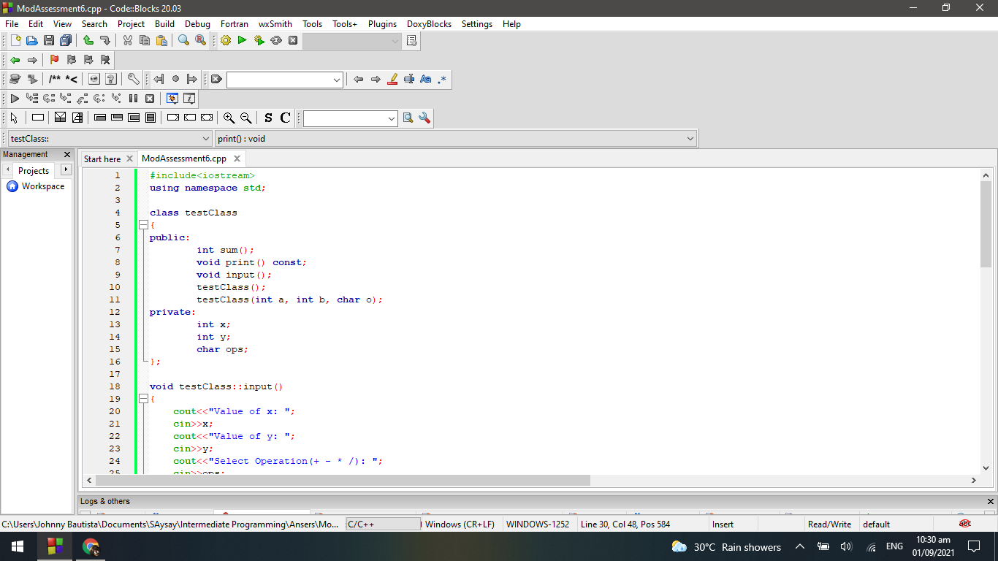

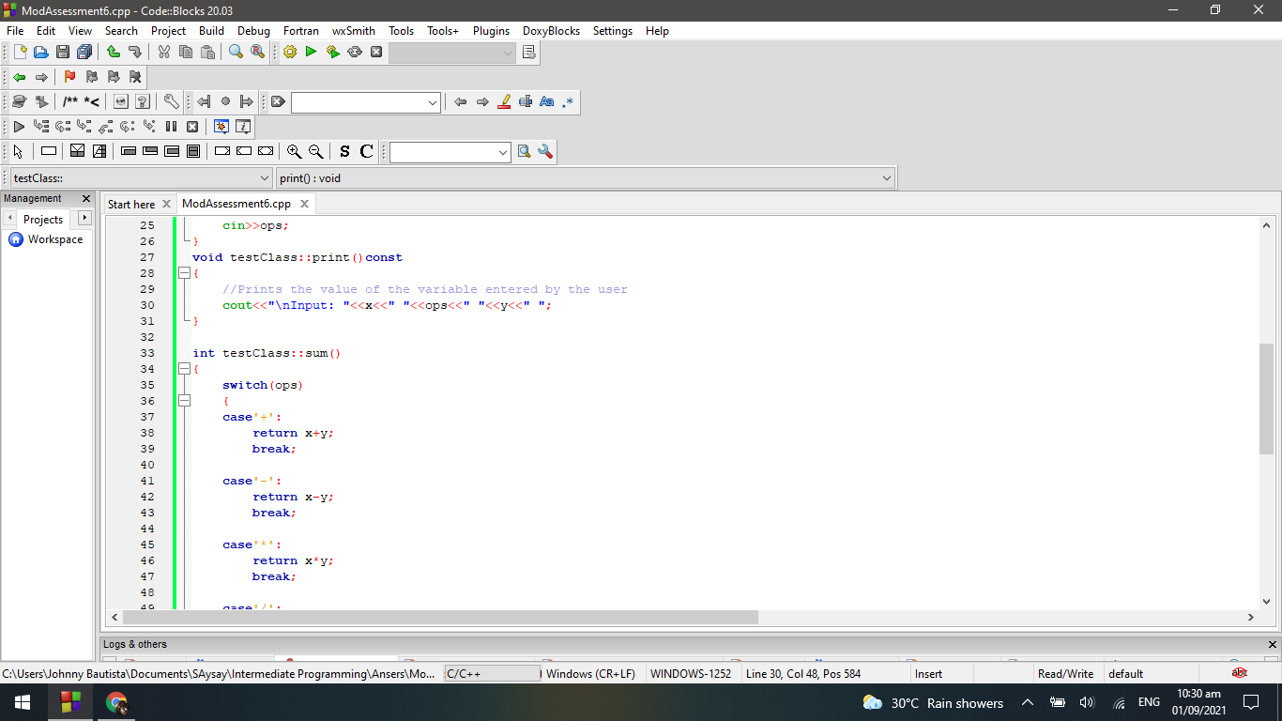

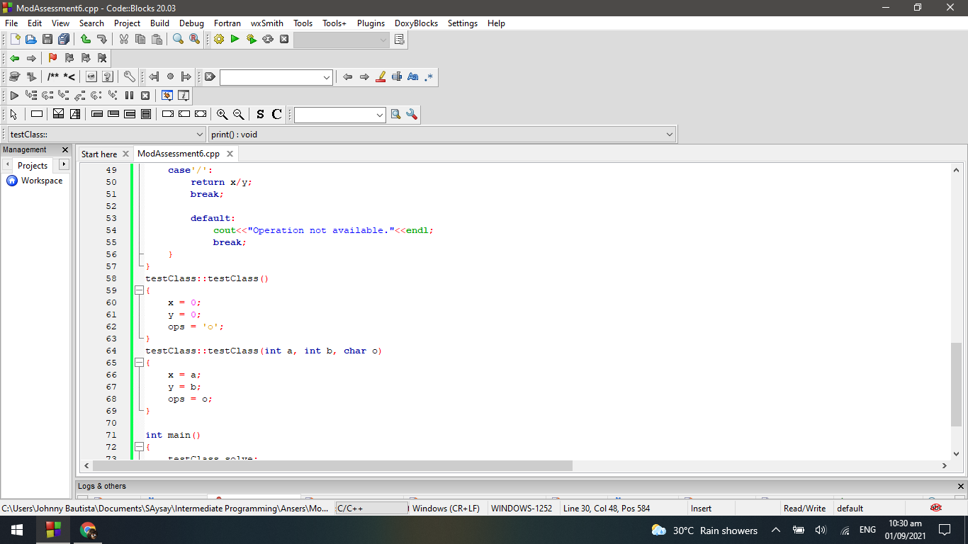

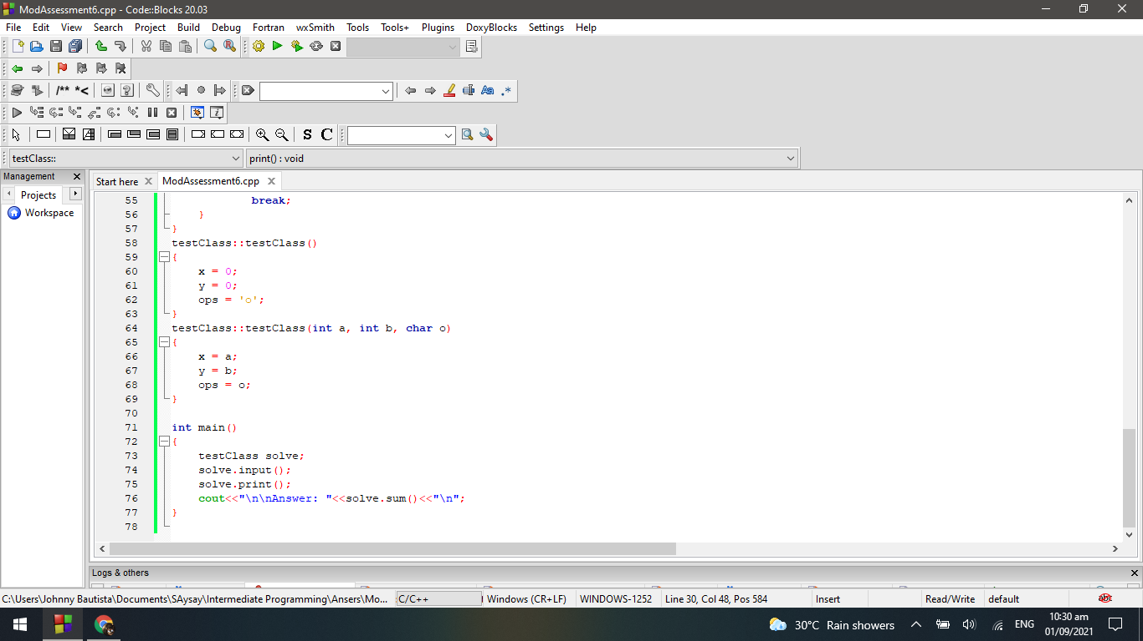

**OUTPUT:**

